- The Monetary Policy Committee voted to hold Bank Rate at 3.75% at its meeting this week. But the vote was unexpectedly tight, and the committee's tone was more dovish than anticipated. We still expect the MPC to cut again by the April meeting, but the door has been opened to move in March if the data surprises to the downside or financial markets clearly price a cut.
- The direction of policy further out is difficult to call. The MPC remains divided, and messaging from individual members has been very inconsistent from one meeting to another. We think the most likely outcome is that the MPC cuts twice in 2026, in March or April and November.
The Bank of England's monetary policy decision was the week's main event. Coming into the February meeting, we viewed a hold as virtually certain and were looking for signals about how the committee's concerns about the strength of pay growth had evolved. In the event, while the MPC kept Bank Rate unchanged at 3.75%, the vote was much tighter than expected and the MPC's tone more dovish.
We had only anticipated two votes for looser policy at this week's meeting, from long-time doves Swati Dhingra and Alan Taylor. But these members were joined by Sarah Breeden and Dave Ramsden in voting for a 25bp cut. In December, Breeden and Ramsden struck a cautious tone on the scope for further easing in the near term, and flagged the strength of forward-looking pay indicators as their main concern. But despite little recent progress in these indicators, Breeden and Ramsden were reassured by BoE staff analysis suggesting that wage growth was on track to fall to a target-consistent pace this year, and that it's less likely there have been structural changes in the labour market that could keep pay growth elevated.
The minutes stated that most committee members thought the upside risk from greater inflation persistence had receded, while some downside risks to inflation from weaker demand and a loosening labour market remained. The MPC's concerns about the strength of activity were shown by it downgrading its 2026 GDP growth forecast to 0.9%, which is in line with our own projection and 0.3ppts below the BoE's November forecast (Chart 1). In combination with a further loosening in labour market conditions, the weaker growth outlook led the MPC to conclude that there would be more slack in the economy.
Chart 1: The BoE's downgraded near-term growth outlook is in line with our own projection
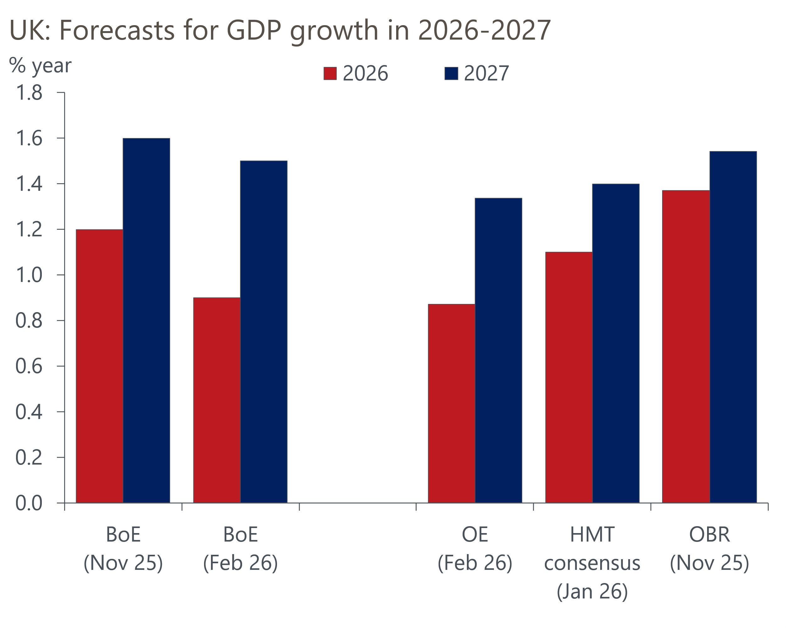
Sources: Oxford Economics, BoE, HMT, OBR

The BoE's decision to downgrade its growth forecast was made despite it shifting the near-term path for inflation markedly lower. This reflected recent data and the impact of Budget measures, such as the removal of some energy levies and a freeze on rail fares. Headline inflation is now projected to fall to 2.1% in April, before returning to the 2% target in June (Chart 2). In the medium term, the BoE now expects inflation to be slightly below target through most of 2027 and into 2028.
Chart 2: The BoE's revised forecast paints a more favourable picture for inflation
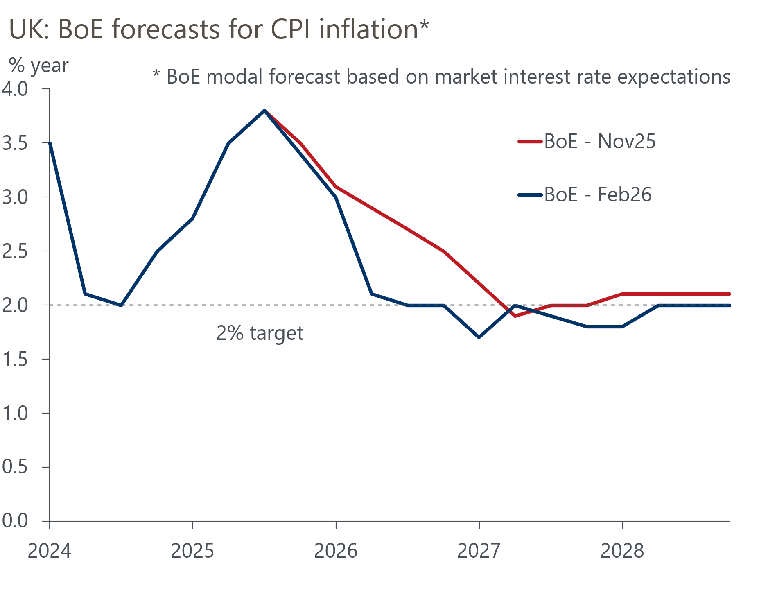
Sources: Bank of England Monetary Policy Report
Overall, the dovish messaging from this week's meeting reinforces our conviction that the MPC is likely to cut Bank Rate again by the end-April meeting. However, the exact timing of the next move has become less clear. We had long-favoured April's meeting for the next cut, on the basis that it would give the committee more time to evaluate the strength of pay growth. But with the MPC's communications downplaying the importance of incoming pay data, and stressing their growing concerns about activity and slack in the labour market, the odds of a cut at the March meeting have become more evenly balanced.
The MPC also tweaked its guidance by removing references to Bank Rate being on a "gradual downward path". The new guidance that "Bank Rate is likely to be reduced further" is vaguer, providing greater flexibility to cut sooner.
In addition, Catherine Mann has become a wildcard. With one notable exception last February, Mann has always been one of the most hawkish committee members. But her paragraph in the minutes said "the appropriate time for a cut in Bank Rate [was moving] closer" while in the summary of the vote, her views were aligned with Governor Andrew Bailey, separate from the other three hawks, Megan Greene, Clare Lombardelli and Huw Pill. Bailey has cast the deciding vote at four of the past five meetings, but the possibility of Mann completing her volte-face offers an additional path to securing a majority for a rate cut.
We regard the March meeting as being little more than a coin toss. If the activity and labour market data published before the March meeting surprise to the downside, or markets decisively price a cut ahead of the meeting, we suspect that would probably be enough to tip the balance in favour of a March cut.
It's hard to have much conviction on the direction of policy further out. The MPC remains deeply divided, and it's unlikely we'll see the run of close votes ending soon. The messaging from specific MPC members remains inconsistent from one meeting to another, leaving us less certain about what each member is looking for. Extra confusion has been caused by the move from data-dependence to a more forward-looking approach that leans on the BoE's forecasts and staff analysis, and the inconsistent use of scenarios.
We think the most likely outcome is that the MPC cuts twice in 2026, in March or April and November. This would leave Bank Rate at 3.25% at the end of the year. In response to a question at the press conference, Bailey offered implicit backing for this call, suggesting that market pricing implying a similar level at the end of the year was "reasonable".

The week ahead
The only economic release of note next week is the GDP data for December, which will complete the picture for Q4 and 2025 as a whole. November saw stronger-than-expected activity growth, but we think this upturn is unlikely to have been sustained. In particular, some services sub-categories recorded sharp increases in November, including professional services and communications activity, suggesting scope for some payback in December. Strikes by resident doctors towards the end of the month are likely to have weighed on output in the health sector. We also suspect the recent recovery in non-automotive parts of manufacturing output has overshot.
As a result, we estimate that GDP fell by 0.1% month-on-month in December. This would leave GDP up 0.1% q/q in Q4, the same pace as Q3, and growth in 2025 as a whole at 1.4%.
Table 1: Week ahead calendar
Date | Events | Period | Measure | Unit | Previous | Forecast
Feb 12 | GDP | Dec | m/m | % | 0.3 | -0.1
Feb 12 | GDP | Dec | 3m/3m | % | 0.0 | 0.1
Feb 12 | Index of services | Dec | m/m | % | 0.3 | 0.0
Feb 12 | Index of services | Dec | 3m/3m | % | 0.2 | 0.1
Feb 12 | Manufacturing output | Dec | m/m | % | 2.1 | -0.7
Feb 12 | Manufacturing output | Dec | y/y | % | 2.1 | 1.1
Feb 12 | Industrial production | Dec | m/m | % | 1.1 | -0.5
Feb 12 | Industrial production | Dec | y/y | % | 2.3 | 0.9
Feb 12 | Construction output | Dec | m/m | % | -1.3 | 0.7
Feb 12 | Construction output | Dec | y/y | % | -1.2 | 0.1
Feb 12 | UK trade | Dec | Trade balance | £bn | -6.1 | -5.3
Feb 12 | UK trade | Dec | Visible balance | £bn | -23.7 | -22.9
Source: Oxford Economics

Key forecasts
Table 2: UK forecast overview
(Annual percentage changes unless specified)
 | 2023 | 2024 | 2025 | 2026 | 2027 | 2028
GDP | 0.3 | 1.1 | 1.4 | 0.9 | 1.3 | 1.4
Private consumption | -0.3 | -0.1 | 0.9 | 1.1 | 1.1 | 1.3
Fixed investment | 0.5 | 1.7 | 3.2 | 0.9 | 2.1 | 2.1
Government consumption | 2.1 | 2.9 | 1.8 | 2.1 | 1.7 | 1.4
Exports of goods and services | -2.3 | 1.4 | 2.1 | 0.9 | 1.1 | 1.3
Imports of goods and services | -1.6 | 2.7 | 4.2 | 0.4 | 1.2 | 1.4
Industrial production | -2.6 | -1.3 | 0.5 | 0.6 | 1.1 | 1.2
Consumer prices | 7.3 | 2.5 | 3.4 | 2.5 | 2.6 | 2.4
Unemployment rate (%) | 4.1 | 4.3 | 4.8 | 5.2 | 5.0 | 4.7
Current a/c balance (% of GDP) | -3.6 | -3.0 | -2.9 | -3.0 | -2.8 | -2.6
Government balance (% of GDP) | 5.2 | 5.3 | 5.0 | 3.9 | 3.3 | 2.8
Central bank policy rate (%, EOP) | 5.25 | 4.75 | 3.75 | 3.25 | 3.00 | 2.75
10yr govt. bond yield (%, EOP) | 3.54 | 4.57 | 4.47 | 4.38 | 3.90 | 3.64
Exchange rate (US$ per £, EOP) | 1.27 | 1.25 | 1.35 | 1.31 | 1.30 | 1.30
Exchange rate (euro per £, EOP) | 1.15 | 1.21 | 1.15 | 1.11 | 1.10 | 1.10
Source: Oxford Economics
Table 3: Quarterly forecasts for the UK
 | 2025 |  |  |  | 2026
 | Q1 | Q2 | Q3 | Q4 | Q1 | Q2 | Q3 | Q4
GDP (% year) | 1.8 | 1.4 | 1.3 | 1.1 | 0.7 | 0.7 | 0.9 | 1.1
CPI inflation (% year) | 2.8 | 3.5 | 3.8 | 3.4 | 3.0 | 2.2 | 2.4 | 2.5
Bank Rate (%, EOP) | 4.50 | 4.25 | 4.00 | 3.75 | 3.75 | 3.50 | 3.50 | 3.25
10yr gilt yield (%, EOP) | 4.70 | 4.48 | 4.70 | 4.47 | 4.50 | 4.50 | 4.46 | 4.38
US$ per £ (EOP) | 1.29 | 1.37 | 1.35 | 1.35 | 1.35 | 1.33 | 1.32 | 1.31
Euro per £ (EOP) | 1.20 | 1.17 | 1.15 | 1.15 | 1.15 | 1.13 | 1.12 | 1.11
Source: Oxford Economics

Latest Country Economic Forecast:
January 22, 2026

Recent publications

Data Insights
January's PMIs probably overstate the economy's momentum
Manufacturing sector made a steady start to the year
Surprise fall in mortgage approvals in December
January PMI looks too good to be true
Quiet end to the year for the retail sector

Research Briefings
Dovish hold prepares the ground for more easing
Would a change in Labour's leadership affect economic policy?
Forecasters' Mailbag – Questions from our conference
MPC preview – Rates on hold amid signs of pay stickiness
Alternative indicators point to subdued economy

Contacts

Oxford Economics' UK team
- Andrew Goodwin - Chief UK Economist - agoodwin@oxfordeconomics.com
- Edward Allenby - Senior UK Economist - eallenby@oxfordeconomics.com

